Analysis Of Logistic Regression

(With Newton’s Method, Assignment # 4)



**Amarjeet Yadav**

**MIT2018053**

**RESULTS**

**1. Logistic Regression + Newton’s + Data set (Examination)**

**1. I . 70 % Training and 30 % Testing**

**Parameters Obtained : For Epochs = 50**

parameters after Newton’s Method implementation = [[4.25798534 5.20246177 5.341987 ]]

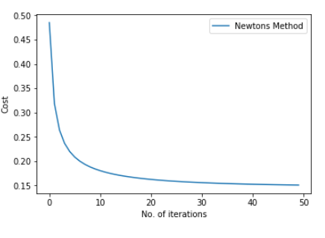

Predictions out of **30** test points is  **26**

**Accuracy achieved** = 86.66666666666667 %

**CONCLUSION**

1. For n < 10^6 go for newton’s method to minimize the cost as it converges faster and for larger value of n go for gradient descent as time complexity of one step of newton’s method is quite high o(n^3).

**Gradient Descent Vs Newton's Method**

1. Gradient Descent is simpler to implement as compare to Newton's Method.
2. In newton’s method no need to choose alpha(learning rate)
3. Newton’s Method has nature of Quadratic Convergence i.e in nearly 15-20 iterations it get converged.
4. Only use Newton’s Method for less number of features as we have to calculate inverse and it’s time complexity is o(n^3).
5. Each iteration of newton’s method time complexity is o(n^3) while gradient as time complexity of o(n^2)